Login Oracle 20171 from home

Here is one way I found to be able to work on Oracle from home. This method does NOT log into your account at Seneca. It involves installing Oracle Express and maintain and working on your own computer. That should not be a problem for most of the semester.

The only small drawback I see at the moment is that you are logged in as SYSTEM at home and your tables are mixed up in a list of 100 other tables.

Download Oracle software

<http://www.oracle.com/technetwork/database/database-technologies/express-edition/downloads/index.html>

Screen looks like thgis

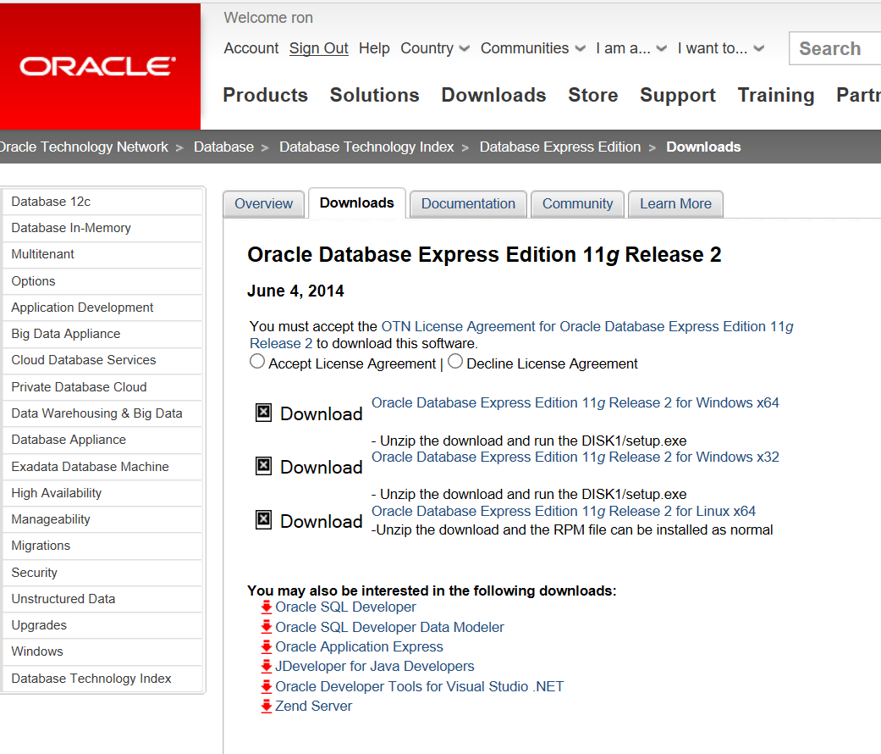

Accept the license and in my case I chose the first download.

Look for a setup file and click on it to start. It should decompress your files. It will ask you where to locate them and should also ask you for a user name and password. I used their suggestion of SYSTEM, but remember the password you choose. (This is not Seneca password). If you forget you are out of luck.

After installation look for SQL Server under Oracle XE or Oracle Express.

Start SQL Developer and this screen comes up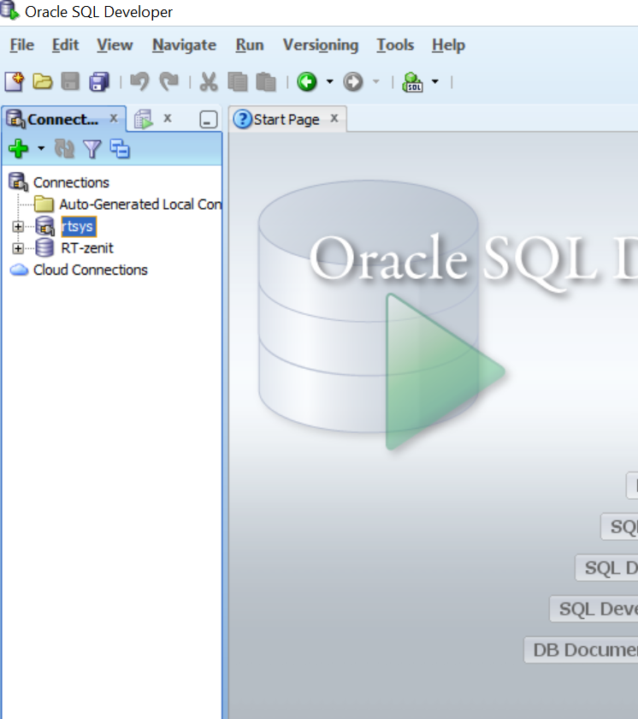

Start a new connection using a different connection name

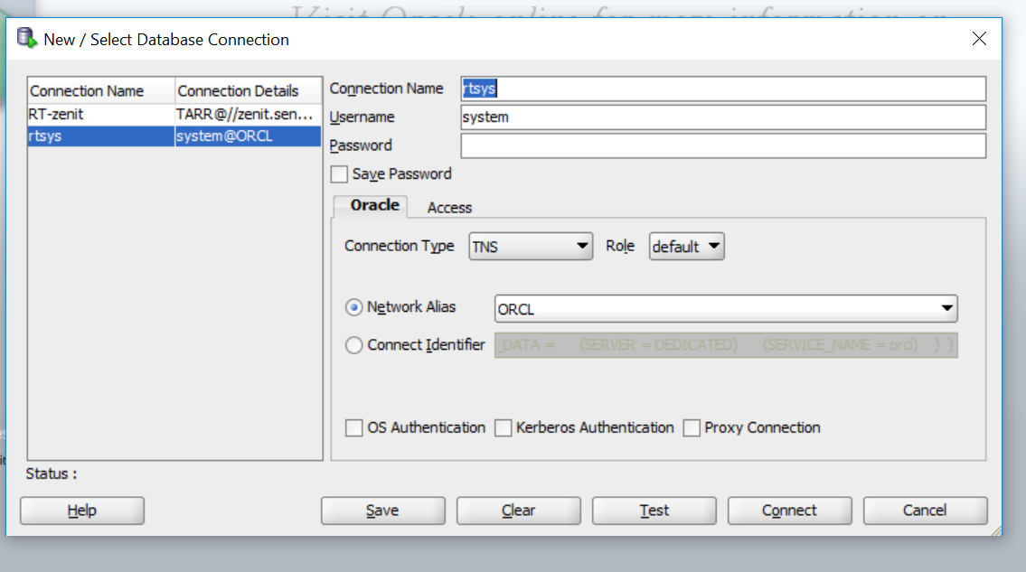

Load demobld10g